I go to Contacts and click on ‘Create Contact’. In this view you need to choose an Account.

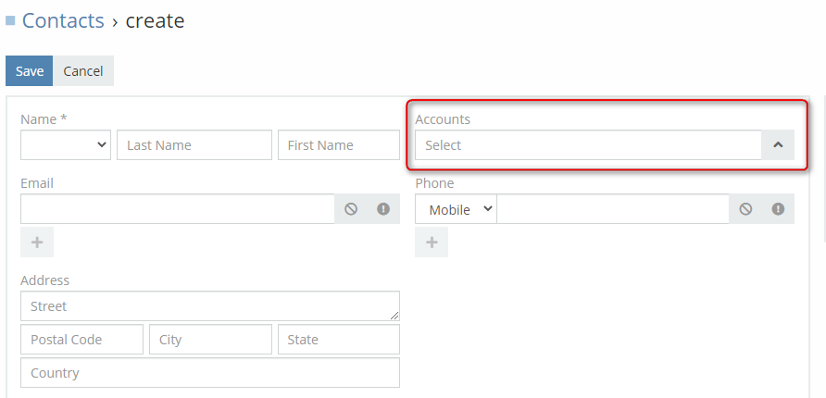

I’ve made a new Entity ‘beschikkingen’. But if I go directly to Beschikkingen in the above menu and click on ‘Create beschikkingen’ there is no field to select Accounts

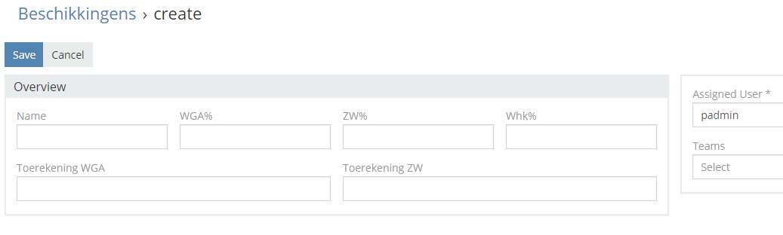

Although I selected ‘Required’ in the field Accounts under de Entity Beschikkingen.

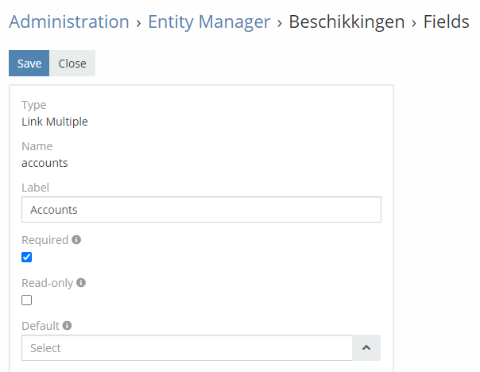

When I go to the layout manager – Contacts - Detail, the Account is available in the panel.

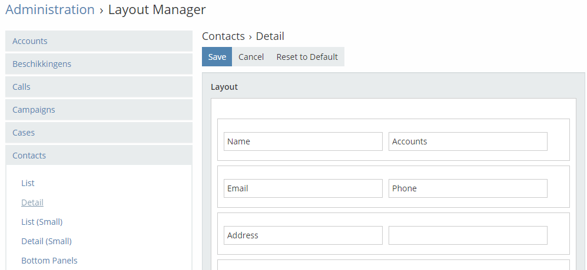

When I go to the layout manager – Beschikkingen – Detail, I can not select the field ‘Accounts’.

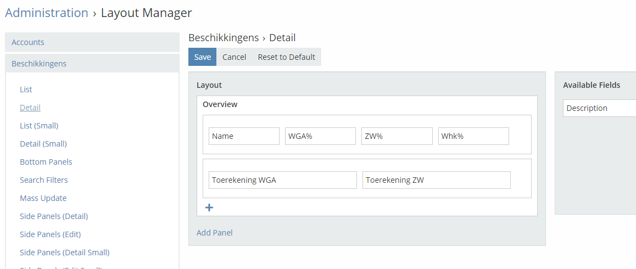

I’ve also added a relationship between Accounts and Beschikkingen

